GP Practice
Address
Telephone Number
Date

Dear
We are contacting you to make sure that we are doing everything we can to make it as easy as possible for you to access health services.

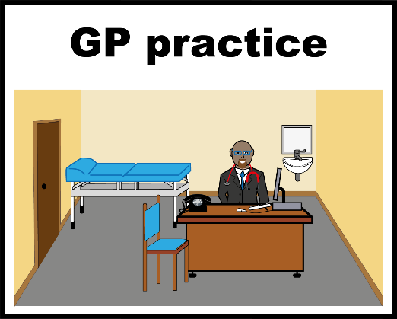
A reasonable adjustment is a small change your GP Practice can make, to make your health appointment or annual health check easier for you.

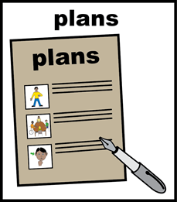

You can tell us about any reasonable adjustments that will help you in the table below.
Please return this letter to your GP surgery, they will add your reasonable adjustments to your health record.
Name  Date of Birth |  | Yes | No | Comment
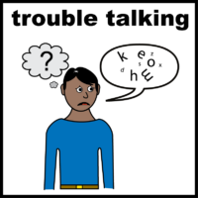 | Do you need us to communicate with you in a particular way?
 | Do you need information in easy Read or large print?
Do you want us to involve someone who gives you support?
This could be a carer, family member, friend or support worker?
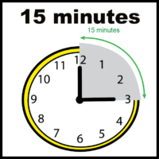 | Do you need a longer appointment?
 | Do you need a reminder about your appointment?
 | Other reasonable adjustments?
Yours sincerely

Dr XXX

For the attention of admin staff
Reasonable adjustments indicated above must be coded in the person’s health record using the below Codes:
9NfA. | Requires information in Easyread
9Nfl. | Requires approach to care to be discussed with carer
9Nfm. | Requires extended appointment
9Nfk. | Requires appointment reminders
9Ngzl. | Requires reasonable adjustment for health and care access (Equality Act 2010)

(Developed by NHS Bury CCG)

